Can we design elaborative fragments as new drug leads for SARS-CoV-2 Nsp13?

Linda Patio 18024104

ABSTRACT xxx

1. INTRODUCTION

1.1 COVID-19 and SARS-CoV-2

Coronavirus disease often denoted as COVID-19 is a viral, airborne infection that causes mild to moderate respiratory disease in most people. Majority of those infected recover without the need for special treatment. [1] Since it is airborne the virus spreads from an infected person’s mouth or nose as small liquid particles when they cough, sneeze, speak or breath. It can also spread indirectly via contaminated surfaces.[3] Unfortunately in some cases, those infected may fall severely ill and require hospitalisation. Often the elderly and those with underlying conditions such as diabetes, those who are immunocompromised or those with chronic respiratory or cardiovascular disease experience more severe symptoms that may result in death.

The first report of such disease was on December 1st, 2019, where clusters of pneumonia of unknown cause were reported in Wuhan City, Hubei Province in China and on the 9th of January 2020, SARS-CoV-2 of zoonotic origin was identified as the causative pathogen of this unknown disease.[3] This virus shares proteome similarity with other coronaviruses that have caused past outbreaks [14], two examples would include SARS-CoV 2002 and MERS-CoV 2012. [13] All three coronaviruses can cause severe respiratory disease [13] however SARS-CoV-2 has been the most lethal; being the cause of mortality of over 5 million people worldwide.[2] Despite this being the case, there are still no approved vaccines or drugs that would treat COVID-19; however, one antiviral medication is undergoing clinical trials, and a few are under consideration.[7]

SARS-CoV-2 is an enveloped, positive-stranded RNA, with one of the largest genome sizes of 30kb.[4] It has a genetic sequence of approximately 80% similarity to SARS-CoV-1 and bat coronavirus RaTG13.[5] As it is a positively charged virus, it can act as a messenger RNA and is also able to be directly translated into viral proteins using the host cell’s replicatory mechanism. [20] The viral envelope is covered with spike (S) glycoprotein that mediates host target receptor binding to the peptidase domain of the angiotensin converting enzyme (ACE 2). Binding consequently leads to host cell entry (**Fig 1)**.

**Figure 1**. Viral cycle of SARS-CoV-2 from BMJ [5]

Upon entry the pH of the cytoplasm causes endosomal acidification that results in the release of viral genome into the host cytoplasm. The virus then utilizes the host ribosomal machinery to translate the positive sense viral RNA genome into two replicative polyproteins pp1a and pp1b, from ORF1 and ORF1b respectively.[6] These polyproteins are processed and cleaved resulting in 16 non-structural proteins (Nsps)[8], which together constitutes the replication transcription complex (RTC) for viral RNA synthesis[8][12]; the pp1a corresponds to nsp1 to nsp11, while pp1b will result in nsp12 to nsp16.[8] These non-structural proteins are vital in SARS-COV-2 viral replication and have many functions, notably Nsp13 functions as an RNA-dependent RNA helicase and Nsp12 as an RNA-dependent RNApolymerase.[8]

1.2 Structure of Nsp13

The Nsps are important components of the replication transcription complex (RTC) of SARS-CoV-2, in this paper the focus will be on the singular helicase encoded and used by the virus, Nsp13. Nsp13 is an RNA-dependent RNA helicase that unwinds dsDNA and dsRNA in the 5’ to 3’ direction.[14] It utilises chemical energy from nucleoside triphosphate hydrolysis and mechanical energy that results in the translocation through nucleic acids and consequently the separation of double stranded nucleic acids. (10)The separation of double stranded nucleic acids is critical as genome transcription and translation relies on single strands for efficient genome replication, repair and recombination. Therefore, defects in the efficiency of helicase function will result in disorders of the affected organism, hence making nsp13 a suitable protein of interest.

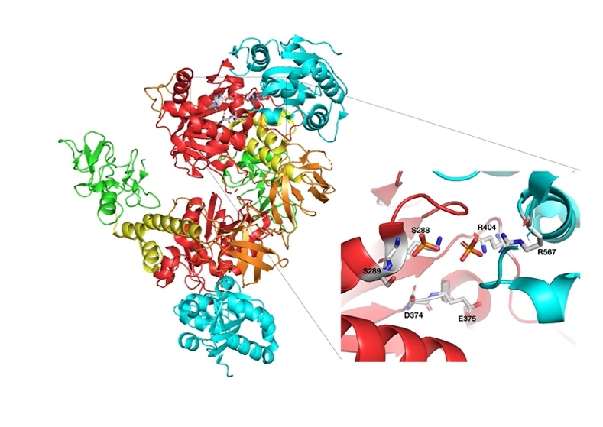

**Figure 2**. Nsp13 structure with phosphate bound (PDB: 6ZSL) and residues for NTPase Activity, Key: Green: ZBD, Yellow: stalk, Red: 1A, orange: 1B and cyan: 2A.

Nsp13 is made up of 601 residues [11] and weighs approximately 67 kDA. Notably it belongs to the helicase superfamily 1B [14][18] and consists of five domains: the Zinc Binding Domain (ZBD), stalk domain, 1A, 2A and 1B domains. All domains form a triangular pyramid structure with the ZBD and Stalk domain pointing towards the apex of the pyramid while the 1A, 2A and 1B domains form the triangular base.[15] In addition to this, all five domains coordinate with each other to complete the final process of nucleic acid unwinding [16]

1A and 2A are Rec A-like helicases that constitute the SF1 helicase core and are important for the catalytic functions of Nsp13.[13][15] They possess NTPase activity in the cleft between them, which means they are involved in nucleic acid binding along with the hydrolysis of ATP.[11] One study superimposed SARS Nsp13 with yeast Upf1-ADP-AIF4[11] and established residues that make up the active site for NTP hydrolysis which are as follows: Lys288, Ser289, Asp374, Glu375, Gln404 and Arg567.(**Fig 2)** [14] It is of vital importance to note that all residues except for S289 are conserved in MERS-NSP13[11] which further testifies the potential for designing broad spectrum antivirals.[15]  In addition to this, they also possess residues that are responsible for nucleotide binding[13], specific contacts are made between the nucleotide and several conserved helicase motifs and can occur in two different modes. [13]

An equally significant function of the rec-A like helicase is the ability of the 2A domain to also facilitate the binding of double-stranded DNA (dsDNA) as what was mentioned previously; it contains two residues on its surface that are critical for this binding, R507 and R508, which are both exposed to solvent.[15]  There are also four important residues that are positioned at the entrance of the nucleic acid binding in the 1A domain that are critical for the unwinding activity of Nsp13: Arg337, Arg339, Lys345 and Lys347.

Subsequently, the 1B domain is involved in the unwinding of dsDNA directly and indirectly [11] by forming a channel with the two Rec-A like helicases. This channel is often described as a beta barrel [13] which consists of 30 amino acid linkers that connects the three domains together. However, the radius of the channel that is formed is not wide enough for dsDNA to pass through [11] suggesting that dsDNA only binds on the outer surface of the protein.[16] In conclusion the 1B, 1A and 2A domains are the main domains that are involved in nucleic acid binding, separation (either directly or indirectly) and ATP hydrolysis.

The SF1 helicase core is connected to the stalk and 1B domains, which is connected to the zinc binding domain (ZBD). The ZBD contains three structural zinc ions, two ions are found in the ring-like module of the N-terminus, and one is found in the treble clef zinc finger.[13] This domain packs against the stalk domain, which is composed of three tightly interacting helices that makes interactions [15] connecting it to the 1B and ZBD domains. [11] In addition to this, two residues, K131 on the A3 helix of the stalk domain and S424 on the 1A domain have been found to provide structural stability for the stalk domain[11], while the third helix of the stalk domain connects to the 1B domain and forms a “6-stranded RIFT type anti-parallel B-barrel”.[13][21] The stalk domain also forms a small interface for the  ZBD, 1A and 2A domains that is composed of hydrophobic and hydrophilic interactions. This arrangement is not flexible but allows the ZBD to regulate the unwinding activity of SARS-Nsp13. [15]

Although the roles of the ZBD and stalk domain in the function of SARS-Nsp13 are still not fully understood,[15][16] some studies have shown they play a functional role in either the integrity of the nsp13 structure or viral replication; specifically, the ZBD region may be involved in replication and transcription [8], as it has 13 cysteine and 3 histidine residues that play vital roles [11]. ZnF1 (Cys5, Cys8, Cys26 and Cys29) and ZnF2 (Cys16, Cys19, His33 and His39) are found at the interface between domains ZBD and 1A. ZnF3 is made up of His75 only and does not interact with other regions of the protein. [11] At the same time there are also six residues that are able to form hydrophobic interactions: V6, L7, I20, F106, L130 and A140, which all cluster together at the interface where the ZBD meets the stalk domain.[11] Based on this study and the observations of the stalk domain structure, it can be concluded that signals are transferred from the ZBD domain down to the helicase core domains that helps regulate the unwinding activity of the helicase.

1.3 What makes Nsp13 a good target for novel antivirals

Many studies have discovered the different roles of nsp13 although the exact role it plays during the viral cycle is still not fully understood it is evident that nsp13 is vital in the efficient functioning of SARS-CoV-2. Some studies have shown that nsp13 interacts with other non-structural proteins such as nsp12. Notably nsp12 can directly enhance the helicase function by increasing the step size of nucleic acid (double stranded DNA or RNA) unwinding by two-fold.[13] It has also been shown that MERS-Nsp12 can increase the helicase activity of SARS-Nsp13 which suggests this interaction occurs across Coronaviruses.[15] The helicase enzyme also acts in concert with the RTC (nsp7/nsp8/nsp12)[13] ,which contributes to the enhancement of its activity by mechanoregulation(16), as nsp12 for example will be able to provide polymerase activity on the relevant nucleic acid.[14][17] Within the same helicase active site, Nsp13 also has triphosphate activity suggesting a role in the formation of the viral 5’ mRNA cap; capping is important for efficient replication.

It should also be considered that helicases in general provide a very attractive target for antivirals as they are ubiquitous enzymes that play a vital role in processing and preparing nucleic acids and protein complexes for viral replication and proliferation to take place. [10] [14] Historically they have been proven to stop proliferation without causing strong adverse drug reactions, which have been seen animal studies of several antivirals that target viral helicases for the treatment of HSV and Hep C. (18) Unlike spike protein which shows great variability (17), all Nsps and Nsp13 specifically show high sequence conservation and essentiality across all coronavirus species (13) differing from SARS-CoV by only one amino acid (V5701) and in the aspect of SARS-CoV-2, it is the singular helicase encoded and utilized. (11) These facts hint the potential that any antiviral targeted towards SARS-CoV-2 Nsp13 can also be effective against SARS-CoV and other future related strains, thus giving it a broad-spectrum activity, which is the ideal in this field.

As the structure of the helicase protein including the postulated functions of its different domains have been determined, it is possible to find ways of inhibiting mechanisms that are vital for viral replication and proliferation. Potential modes of inhibition could involve inhibiting the binding of ATP and nucleic acids or by blocking helicase translocation. (17) A few studies have already conducted experiments using pre-existing medicines and studying the potential for repurposing clinically used drugs for the treatment of Covid-19. Most importantly one paper has established the existence of fragments that are able to bind to the helicase, which will be mentioned later on.

1.4 Known inhibitors of Nsp13

One study looked at the possibility of repurposing FDA approved antivirals drugs as dual inhibitors. Simeprevir (PubChem ID: 24873435), Paritaprevir (PubChem ID:45110509) and Grazoprevir (PubChem ID: 44603531) were common leads identified during this screening which showers higher binding affinity to both nsp13 and nsp14. Binding affinities obtained were -10.42, -9.70 and -9.23 respectively. (14) These three drugs were able to form multiple hydrogen bonds and hydrophobic interactions with key residues lining the active site and binding pockets. (14) Other compounds that are able to inhibit the mechanisms of Nsp13 are benzotriazole, imidazole, quinolone, anthracycline and others. (17) Bananin derivatives were also found to inhibit the ATPase activity of SARS-CoV helicase (8) with IC50 values ranging from 0.5 to 3 μM (23)

Furthermore, a key paper published on Nature, presented results from an X-ray crystallographic fragment screen that showed 65 fragments binding to Nsp13 in 52 different datasets. (13) This experiment used the phosphate-bound nsp13 crystal and soaked 648 crystals with a library of chemical fragments at ~50mM final concentration. According to this study (13) fragments bound to two predicted pockets that were of functional importance and are “conserved in the entire SARS-CoV-2 proteome”; they are the nucleotide binding site and RNA/DNA binding channel. 15 fragments bound to the nucleotide binding site (Figure 3) and found to be in positions that overlapped the ATP ribose and adenine moiety. Notably 3 of these fragments (5RLI, 5RLJ and 5RLW) contained sulphonamide functional groups that made polar contacts to key residues within motif I and the phosphate ion occupying the a-phosphate position. The rest of the fragments bound to further regions within the pocket occupied by the adenine moiety and made interaction with nearby residues such as, H290, K320, Y342, R442 and N464.

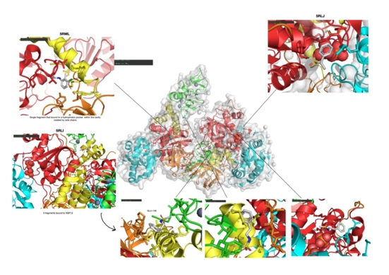

**Figure 3**. Fragments that bound to the nucleotide binding site

On the other hand, fragments that bound to the second predicted druggable pocket, which is the RNA/DNA binding channel, were quite scattered. A few fragments (5RLH, 5RLZ and 5RMM) (Figure 4) bound to a pocket formed between the 2A and 1B domains; this pocket is close to the 5’ end of the channel, they determined that the polar contacts made with key residues were identical to the interactions formed after two successive RNA phosphates in the structure of the related UPF1 helicase attached to RNA. (14) One fragment occupied the central cavity of the channel which is predominantly hydrophobic, and two fragments bound near the RNA interface where the 3’ end of RNA is expected to exit (5RL8 and 5RMC), these two fragments would therefore be able to block RNA from entering the cleft (Figure 5)

**Figure 4**. Fragments 5RLZ, 5RMM,5RLH that bound to the nucleic acid binding site

A computational approach was used to find potential druggable binding on these Nsp13 structures. The AMP-PNP binding site which is found at the interface of the 1A and 2A domain had a draggability score of 0.91, while the pocket that is formed by domains 1A, 1B and 2A which occupies the 5’ end of the RNA had a draggability score of 1.03. Therefore, it is evident that it is possible to use these fragments as starting points for designing RNA competitive inhibitors, along with the other known inhibitors of Nsp13 to guide designing of new compounds.

**Figure 5**. Fragments 5RMC, 5RML, 5RLK, 5RL8 that bound to the nucleic acid binding site.

1.5 Current Drug Development for Covid-19

In Europe there are currently only three medicines approved by the EMA: Remdesevir, Regdanvimab and Ranopreve (casirivimab/imdevimab combination) [2], which are all given as infusion. All three do not target the helicase protein; Remdesevir acts as a nucleoside analogue and inhibits the RNA-dependent polymerase (RdRp) (25), Regdanvimab on the other hand is a recombinant IgG1 monoclonal antibody that binds to the receptor binding domain of spike (S) protein of SARS-CoV-2 (26). Finally, Ranopreve is a mixture of two recombinant human mABs, Casirivimab and Imdevimab, which both bind to “non-overlapping epitopes of the spike protein receptor binding domain”.

These medicines need to be given early in the infection and thus require the ability to diagnose infections rapidly and gaining quick access to medical settings, which can prove to be an obstacle in less economically privileged countries. In addition to this, biologics such as the current approved EMA medicines will require special storage and distribution and will be expensive to purchase and administer making it less feasible for global supply especially to LMICs. Therefore, novel small molecular agents would be more ideal to obtain better global distribution and availability for all. There has only been one approved antiviral called molnupiravir [3] that can be taken orally, but more oral anti-virals are required to give healthcare professionals more choice when prescribing antivirals especially if some cause adverse effects or are unsuitable for special patient groups such as during pregnancy.

1.6 Aims of Current Project

Thus, in response to the need for new oral antivirals against SARS-CoV-2 and the information already mentioned, this paper will be pursuing the answer to the following hypothesis: ​​“Can we design elaborative fragments as new drug leads for SARS-CoV-2 Nsp13?". Work will be conducted with the StructureGenomicsConsortium (SGC) team and will also be open science based. Links to the GitHub page can be found in the Experimental section.

New drug compound designs will follow the fragments from the Nature paper that were shown to bind to Nsp13 and will be optimised to gain tighter binding. Online software will be used to assess binding affinities, poses and structure of compounds. Specifically, the research will focus on a site called C-terminus B, which is located in the 2A domain.

3. RESULTS AND DISCUSSION

3.1 Establishing a pharmacophore

In response to the work published in Nature regarding small molecular compounds that bound to Nsp13, the StructureGenomicsConsortium team came up with a pharmacophore (Fig.7) that summarised the key interactions produced by the soaked fragments with the helicase protein. For the purpose of this master’s project, it was crucial to replicate this study and establish whether the interactions were justifiable.

**Figure 6**. 5RM3, 5RM6, 5RM9, 5RMG and 5RMJ bound to Site 3 with chemical structures

By analysing the fragment cluster, five fragments were found to bind to C-terminus B (Site 3) which are as follows: 5RM3, 5RM6, 5RM9, 5RMG and 5RMJ (Fig.6). Notably, both 5RMG and 5RM3 make polar interactions via hydrogen bond formation with Glu591. 5RM3 also makes an additional hydrogen bond with Glu591 via its primary amide group, and its pyrimidine group forms a pi-cation interaction with Arg502. This pi-cation interaction is formed as a result of the stabilisation of the electron cloud found on the aromatic ring when it comes in contact with a positively charged moiety which in this case would be the protonated amine group of Arg502. The same pi-cation interaction is established in fragments 5RMJ and 5RMG. In particular the three C-F bonds of 5RM3 are highly electronegative which enables the fragment to form strong hydrophobic interactions with the hydrophobic pocket constituted by residues Phe499 and Val495. The same hydrophobic pocket is utilized by 5RM6 via its two methyl group branches and 5RMG via its benzene ring. 5RM6 is also able to form pi-pi stacking interaction with residue Phe472 via its pyrazole group. In line with this, fragment 5RM9 also interacts with Phe472, but through a pi-cation interaction with the nitrogen in the pyrrolidine group of Phe472. Further study of the C-terminus site concluded that the binding site was predominantly hydrophobic due to the types of amino acid residues that lined the site, which justifies the importance of aromatics and hydrophobic functional groups.

**Figure 7**. Diagram of pharmacophore and explanation of interaction

Taking all of this into consideration, a pharmacophore was determined (Fig.7) which outlined the key functional groups that should be present in new fragment designs. Firstly, a hydrophobic region needs to be present which can be achieved by aromatic rings such as benzene and as seen with fragments 5RM9, 5RM6 and 5RM3 additional groups such as methyl groups and highly electronegative atoms such as fluorine and chlorine can be added to increase hydrophobicity and thus ensure tighter binding with the residues Phe499 and Val495. Secondly, this aromatic ring can be connected directly to a polar group so that interactions can be made with Arg502. The majority of the fragments analysed in this initial stage utilised an amide group. Amide groups may be more favoured than carboxylic acid because the NH2 of the amide group has a higher tendency due to higher polarity to form hydrogen bonds compared to the OH group of carboxylic acids. Thirdly another aromatic ring can be added to not only increase molecular size but also increase hydrophobicity as the surrounding residues are hydrophobic (Leu590, Met474, Ile592). In addition to this second aromatic moiety, an electronegative atom such as nitrogen or sulphur can be incorporated to this aromatic ring to make an additional hydrogen bond with Arg503 or Arg502. According to the initial analysis, it was noted that the second ring may form better orientation if it is smaller so that it becomes three atoms away from the other aromatic ring. After this second ring, a linker chain can be utilised to increase hydrophobicity and molecular size; this also gives the opportunity for future fragment designs to explore the wider vicinity of Site 3 and perhaps find polar residues to form strong interactions.

3.2 Analysis of UCL made compounds

After determining a suitable pharmacophore, fragments were designed. This part of the project involved the analysis of newly designed compounds by the UCL team and ranking them in terms of minimised affinity. The following compounds can be seen in **Fig. 8**. JH-A2 was the compound with the highest mean minimised affinity, followed by TK 2-1, EGT-563, JH-A1 and then TK 1-1; values were -4.87, -4.24, -4.19, -4.17 and -4.00 respectively. Looking at JH-A2, it had 46 different conformations with about half of the poses achieving a minimised affinity of -5.00 or greater. The best pose can be seen as folded and more situated within the binding site making strong interactions with Glu498 and Met498 via dipole-dipole interactions. The formation of these interactions can be explained by the presence of permanent dipoles in the sulphur atoms of methionine, which are formed due to the large difference in electronegativity between the sulphur and carbon; dipoles are also present in the C-F bond of the ligand. This dipole results in the unequal sharing of electrons and thus the formation dipole-dipole interactions. In addition to this, JH-A2 forms pi-pi cation interactions with the benzene ring (3.7-4.9 Å) and one hydrogen bond with the amine group of Asn503. Comparing this pose with a less tightly bound pose (Min. affinity = -3.85), a clear difference can be seen, as the ligand is inverted, with the thiophene group making interactions with the hydrophobic pocket of Val 495 and Ley 590 instead of the tetra-fluorine end. This justifies the need for a polar group to be attached to the second aromatic ring to ensure that the ligand binds correctly and more tightly.

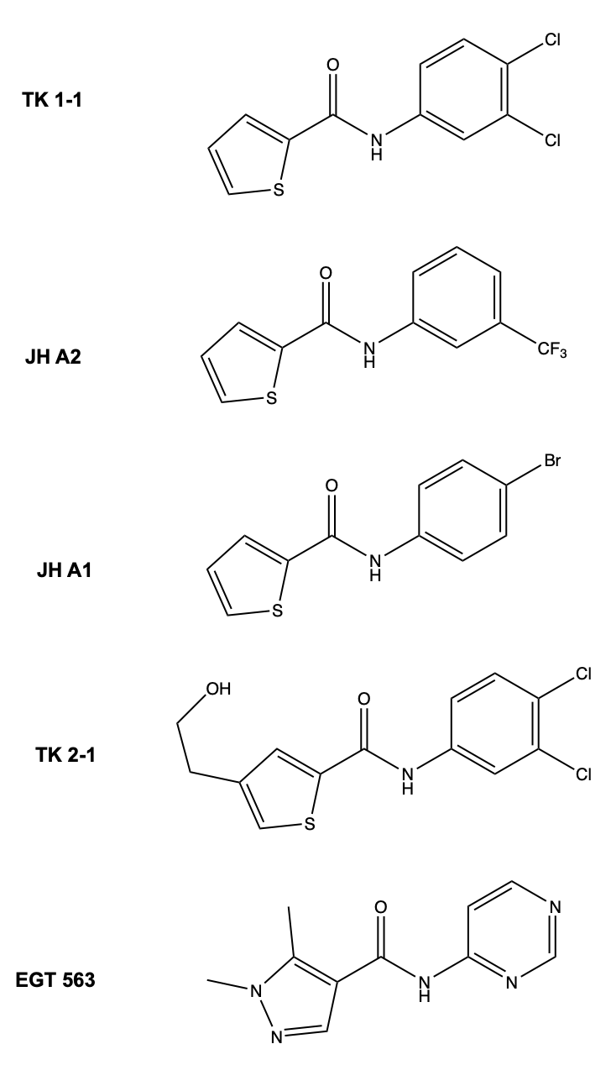

**Figure 8**. Compounds designed by UCL team

But we should also consider, if the correct orientation of the ligand is essential as the second and third best ligands show that inverted binding can result in better minimised affinities (TK 2-1 and EGT-463). Ligand TK 2-1 does not make as much hydrophobic interactions as JH-A2; alternatively, it makes multiple hydrogen bonds via the NH in the amide of the ligand with Glu591 and Ile592 and two additional bonds via the hydroxyl group at the end of the aliphatic chain. The hydroxyl group interacts with Val495 and Glu498 and all hydrogen bonds are quite strong especially between the hydroxyl and Glu498. Similar interactions can be seen with the second-best pose of TK 2-1, but an extra pi-pi cation interaction is formed with Ile592. It can be seen from the analysis above that it is not necessarily required to design fragments to interact with the hydrophobic pocket formed by Arg502 and Val495, but hydrogen bond formations can be maximised. However, making the ligand too polar should be avoided as the Site 3 surface is mainly hydrophobic as mentioned earlier.

3.3 Analysis of enamine compounds

In line with the search for better ligands, a search was conducted on Enamine that determined compounds that bound with high affinity. 10 compounds were found with a mean minimised affinity ranging from -5.54 to -3.45, but individually some compounds were achieving values of greater than -6.00 such as compounds 59479544 and 138540345, which form now will be denoted as compounds 44 and 45. It is worthy to note that compared to the compounds designed and synthesised by UCL, the enamine compounds were much bigger which could be one explanation for their tighter binding.





**Figure 9.** Enamine compounds 44 (top) and 45 (bottom)

A careful analysis of the interactions formed in pose 118 of compound 44 (fig.9), which obtained the highest minimised affinity score revealed the utilisation of three hydrophobic interactions that were not present in the pose with the lowest affinity score. The ligand made interactions with the hydrophobic pocket Phe499 and Val495, and Leu590 and two forms of interactions were made with Arg502: a hydrogen bond and a pi-cation interaction. Compound 44 therefore shows that hydrophobicity is crucial and is as important as polar interactions. Similarly compound 45 (fig.9) also made hydrophobic interactions with Phe499 and Val495, but further hydrogen bonding was made with Glu 591, Asn503 and Arg502. The extra hydrogen bond with Glu591 that was not present in the conformation with the lowest affinity score enabled the ligand in that particular pose to bind much tighter to the active site and also brings the N-H from the pyrrole closer to Arg502, thus forming another hydrogen bond.

Relative to the positive impact of hydrophobicity in ligand binding, I endeavoured to experiment with optimising the enamine compound 44 to justify whether increasing hydrophobic interactions would improve binding. The main structure of the compound was kept, but key changes were made on the methyl branch near fluorobenzene. As what was seen in one pose, the ligand is able to come in close contact with an aromatic ring from Phe499 (3.5 Å), keeping this in bind the following optimisations were made (**fig.10**):

1. Additional benzene ring added to methyl branch
2. Two fused aromatic rings

The rationale behind adding benzene was not only to increase hydrophobicity but also to increase molecular mass, which is an important factor to consider when trying to improve ligand binding. The additional benzene ring may also be able to form pi-staking interactions with the aromatic ring of Phe-499. After docking the optimised fragments, compound 44.1 achieved the highest mean affinity score of -5.83 with a range of -4.58 to -7.02. In addition to this approximately 76% of conformations bound with an affinity of greater than -5.5. Compound 44.2 also showed improved affinity with a mean affinity of -5.63 (Fig.11).





**Figure 10.** Optimised compound 44.1 (top) and 44.2 (bottom)

|  |  |  |
| --- | --- | --- |
| Compound | Mean minimised affinity | Minimised affinity range |
| 44 original | -5.54 | -4.49 to -6.34 |
| 44.1 | -5.86 | -5.58 to -7.02 |
| 44.2 | -5.63 | -4.57 to -6.63 |

**Figure 11.** Table comparing mean and range minimised affinity of compound 44 and its optimised fragments

**Figure 12.** Compound 44.1 pose 1 with affinity of -7.02 shown in green. Site 3 residues within 5.0 Å shown in cyan.

Despite compound 44.1 not directly aligning with Phe499 to make pi-stacking interaction, the extra benzene ring was able to situate itself in a hydrophobic pocket formed by the aromatic rings of Phe499 and Phe472 and the dimethyl branch of Leu590. Three polar interactions were formed with the guanidino group of Arg502. Though the aromatic characteristic of compound 44 was questionable, the addition of non-polar groups justified that increasing hydrophobicity of the ligands can increase affinity.

3.4 Optimising UCL made compounds

Å

4. CONCLUSIONS

5. EXPERIMENTAL SECTION

Fragment Based Drug Discovery

Workflow

Pymole

Have link to appendix for distance ranges

ChemDraw 20.1

Data Warrior

LabArchives

6. REFERENCES

1. Coronavirus (2021) *Who.int* [online]<https://www.who.int/health-topics/coronavirus#tab=tab_1>

2. WHO Coronavirus (COVID-19) Dashboard (2021) *Covid19.who.int* [online] <https://covid19.who.int/> (Accessed December 13, 2021).

3. COVID-19: epidemiology, virology and clinical features (2021) *GOV.UK* [online] <https://www.gov.uk/government/publications/wuhan-novel-coronavirus-background-information/wuhan-novel-coronavirus-epidemiology-virology-and-clinical-features#transmission> (Accessed December 13, 2021).

4. Spratt, A., Gallazzi, F., Quinn, T., Lorson, C., Sönnerborg, A., and Singh, K. (2021) Coronavirus helicases: attractive and unique targets of antiviral drug-development and therapeutic patents. *Expert Opinion on Therapeutic Patents* 31, 339-350

5. Cevik, M., Kuppalli, K., Kindrachuk, J., and Peiris, M. (2020) Virology, transmission, and pathogenesis of SARS-CoV-2. *BMJ*, 1-2

6. Spratt, A., Gallazzi, F., Quinn, T., Lorson, C., Sönnerborg, A., and Singh, K. (2021) Coronavirus helicases: attractive and unique targets of antiviral drug-development and therapeutic patents. *Expert Opinion on Therapeutic Patents* 31, 339-350

7. COVID-19: EMA starts rolling review of molnupiravir - European Medicines Agency (2021) *European Medicines Agency* [online] https://www.ema.europa.eu/en/news/covid-19-ema-starts-rolling-review-molnupiravir (Accessed December 13, 2021).

8. Yadav, R., Chaudhary, J., Jain, N., and Chaudhary, P. (2021) Role of Structural and Non-Structural Proteins and Therapeutic Targets of SARS-CoV-2 for COVID-19. *Cells* 10, 821

9. Spratt, A., Gallazzi, F., Quinn, T., Lorson, C., Sönnerborg, A., and Singh, K. (2021) Coronavirus helicases: attractive and unique targets of antiviral drug-development and therapeutic patents. *Expert Opinion on Therapeutic Patents* 31, 339-350

10. helicase | Learn Science at Scitable (2021) *Nature.com* [online] https://www.nature.com/scitable/definition/helicase-307/#:~:text=Helicases%20are%20enzymes%20that%20bind,each%20strand%20to%20be%20copied (Accessed December 13, 2021).

11. Jia, Z., Yan, L., Ren, Z., Wu, L., Wang, J., Guo, J., and Zheng, L. (2019) Delicate structural coordination of the Severe Acute Respiratory Syndrome coronavirus Nsp13 upon ATP hydrolysis. *Nucleic Acids Research* 47, 6538-6550

12 Yan, L., Zhang, Y., Ge, J., Zheng, L., and Gao, Y. (2020) Architecture of a SARS-CoV-2 mini replication and transcription complex. *Nature Communications* 11

13. Newman, J., Douangamath, A., Yadzani, S., Yosaatmadja, Y., and Aimon, A. (2021) Structure, mechanism and crystallographic fragment screening of the SARS-CoV-2 NSP13 helicase. *Nature Communications* 12

14. Gurung, A. (2020) In silico structure modelling of SARS-CoV-2 Nsp13 helicase and Nsp14 and repurposing of FDA approved antiviral drugs as dual inhibitors. *Gene Reports* 21, 100860

15. Jia, Z., Yan, L., and Ren, Z. (2019) Delicate structural coordination of the Severe Acute Respiratory Syndrome coronavirus Nsp13 upon ATP hydrolysis. *Nucleic Acids Research* 47, 6538-6550

16. Mickolajczyk, K., Shelton, P., Grasso, M., Cao, X., Warrington, S., Aher, A., Liu, S., and Kapoor, T. (2020) Force-dependent stimulation of RNA unwinding by SARS-CoV-2 nsp13 helicase.

17. Habtemariam, S., Nabavi, S., Banach, M., Berindan-Neagoe, I., Sarkar, K., Sil, P., and Nabavi, S. (2020) Should We Try SARS-CoV-2 Helicase Inhibitors for COVID-19 Therapy?. *Archives of Medical Research* 51, 733-735

18. Jang, K., Jeong, S., Kang, D., Sp, N., Yang, Y., and Kim, D. (2020) A high ATP concentration enhances the cooperative translocation of the SARS coronavirus helicase nsP13 in the unwinding of duplex RNA. *Scientific Reports* 10

19. Fairman-Williams, M., Guenther, U., and Jankowsky, E. (2010) SF1 and SF2 helicases: family matters. *Current Opinion in Structural Biology* 20, 313-324

20. 9. Positive-strand RNA virus - Wikipedia (2021) *En.wikipedia.org* [online] <https://en.wikipedia.org/wiki/Positive-strand_RNA_virus> (

21. 10. Coles, M., Hulko, M., Djuranovic, S., Truffault, V., Koretke, K., Martin, J., and Lupas, A. (2006) Common Evolutionary Origin of Swapped-Hairpin and Double-Psi β Barrels. *Structure* 14, 1489-1498

22. 11. Koonin, E., and Moss, B. (2010) Viruses know more than one way to don a cap. *Proceedings of the National Academy of Sciences* 107, 3283-3284

23. 12. Tanner, J., Zheng, B., Zhou, J., Watt, R., Jiang, J., Wong, K., Lin, Y., and Lu, L. (2005) The Adamantane-Derived Bananins Are Potent Inhibitors of the Helicase Activities and Replication of SARS Coronavirus. *Chemistry & Biology* 12, 303-311

24. COVID-19 treatments - European Medicines Agency (2021) *European Medicines Agency* [online] <https://www.ema.europa.eu/en/human-regulatory/overview/public-health-threats/coronavirus-disease-covid-19/treatments-vaccines/covid-19-treatments> (Accessed December 5, 2021).

25. Kokic, G., Hillen, H., Tegunov, D., Dienemann, C., Seitz, F., Schmitzova, J., Farnung, L., Siewert, A., Höbartner, C., and Cramer, P. (2021) Mechanism of SARS-CoV-2 polymerase stalling by remdesivir. *Nature Communications* 12

26. 2. Regdanvimab: Uses, Interactions, Mechanism of Action | DrugBank Online (2021) *Go.drugbank.com* [online] https://go.drugbank.com/drugs/DB16405 (Accessed December 13, 2021).

27. 3. Summary of Product Characteristics for Ronapreve (2021) *GOV.UK* [online] <https://www.gov.uk/government/publications/regulatory-approval-of-ronapreve/summary-of-product-characteristics-for-ronapreve> (Accessed December 13, 2021).